**IT24101462_Lab_06**

**Cooray N T Y**

Q1)

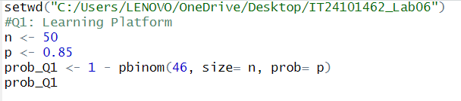

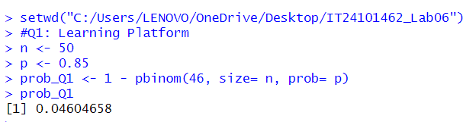

Q2)

